# Working Document for Benefits of ISFR Paper

**By:** Sydney Do

**Start Date of Task:** 2/7/2015

**Objective:** Develop a functional habitat model to support the benefits of ISFR paper

**Boundary Conditions:**

* **Habitation architecture:** Habitation Development Unit (now called HERA)
* **ECLSS:** Baseline Mars surface ECLSS
* **Crew Size:** Sustain 4 crew indefinitely
* **Atmosphere**: EAWG defined

**Initial working filing:** HDUwithEVAandPlantChamberUpdated.m

**Food growth –** check papers on VEGGIE and design of atrium for plant growth area

Read CxP Scenario 12.1

Read A Dual-Chamber Hybrid Inflatable Suitlock (DCIS)

**Habitation Architecture**

*The habitat architecture chosen for this study is representative of the current state of the art in surface habitats for a 4 person extended stay crew on a planetary surface for 180 day missions*

The habitat architecture chosen for this study is based on the Habitat Demonstration Unit that arose from Lunar outpost studies performed during the Constellation Program Scenario 12.1 lunar studies, and has been tested in D-RaTs from 2010-11. As depicted in Figure…, the habitat consists of four main modules. These are the:

* Pressurized excursion module, where all laboratory activities are conducted. This includes general and spacesuit maintenance, medical operations, telerobotics, and scientific activities
* Exploration loft, which houses the crew quarters for four crew members, exercise equipment, as well as…
* Hygiene and Health Module, were all wet activities including … are performed; and the
* DCIS suitlock, a hybrid suitport and airlock which was originally planned for testing during Desert RATS, but not built due to budgetary constraints. Currently, the DCIS represents the most favored airlock for future transit and surface habitats *(REF DCIS paper)*

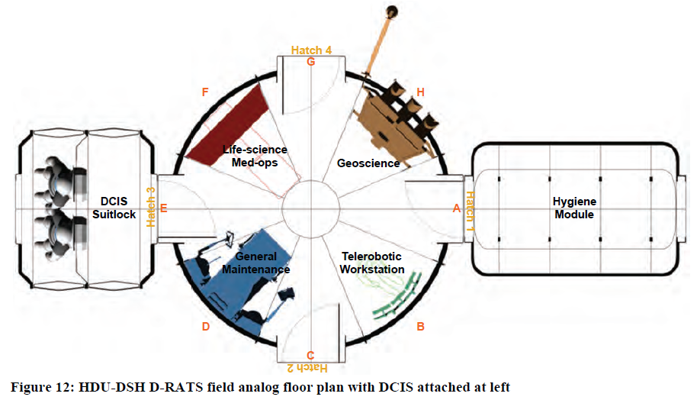

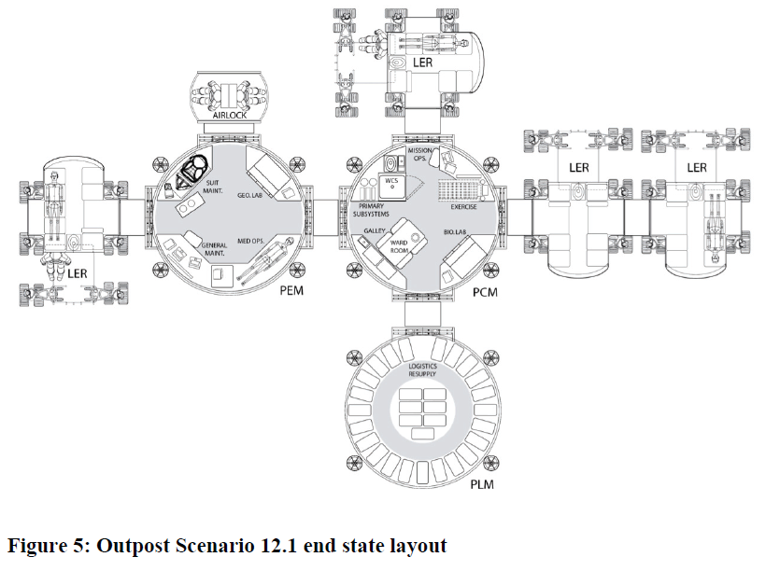

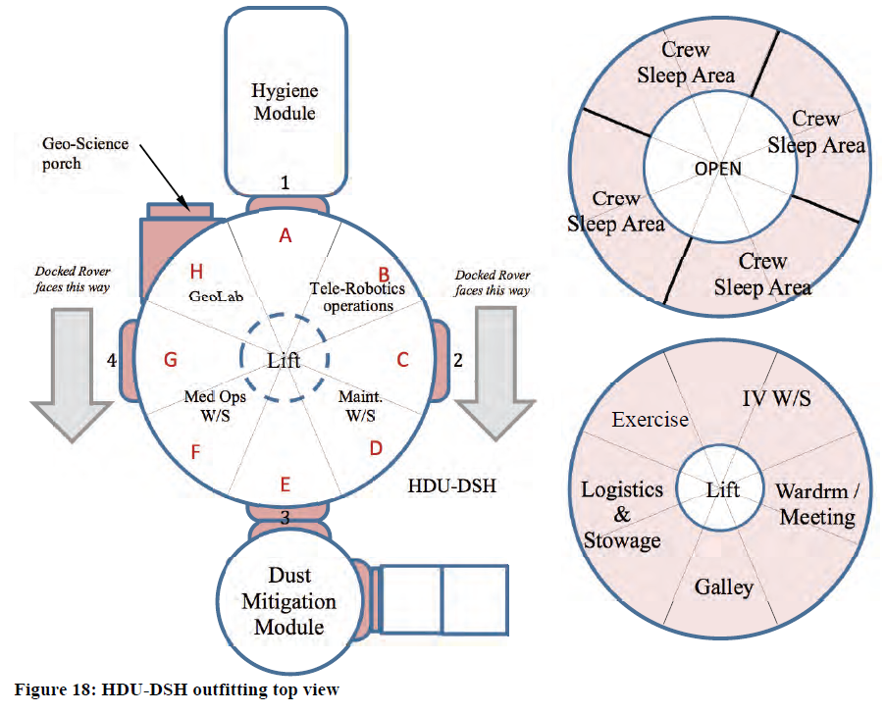

PCM is like Node 3 – contains, ECLSS, WCS and Exercise

Loft contains – wardroom, galley, stowage, workstations, and crew quarters

Place lettuce machine within Loft (near galley) – since a lift tunnel is required to install the plant atrium

**Summary of Simulation Runs**

With lettuce machine and no ISRU:

Error messages:

Simulation Run Started: 15-Feb-2015 17:15:02

Baseline Simulation Run

Insufficient resources available to fill current Store. Filling store with as many resources as is available

Insufficient O2 for crew EVA prebreathe or EMU suit fill at tick: 5603

Current EVA has been skipped

Insufficient O2 for crew EVA prebreathe or EMU suit fill at tick: 5619

Current EVA has been skipped

Insufficient O2 for crew EVA prebreathe or EMU suit fill at tick: 5622

Current EVA has been skipped

Insufficient O2 for crew EVA prebreathe or EMU suit fill at tick: 5634

Current EVA has been skipped

Insufficient O2 for crew EVA prebreathe or EMU suit fill at tick: 5637

Current EVA has been skipped

Male 2 is currently suffocating on tick: 5644 in module: Pressurized Core Module

Female 2 is currently suffocating on tick: 5647 in module: Pressurized Core Module

Female 1 is currently suffocating on tick: 5660 in module: Pressurized Core Module

Insufficient O2 for crew EVA prebreathe or EMU suit fill at tick: 5660

Current EVA has been skipped

Female 2 is currently suffocating on tick: 5662 in module: Pressurized Core Module

Female 2 is currently suffocating on tick: 5663 in module: Pressurized Core Module

Male 1 is currently suffocating on tick: 5664 in module: Pressurized Core Module

Female 2 has died from lack of oxygen (hypoxia) on tick: 5665 with a risk value of: 0.46552

Female 2 has been killed

Elapsed time is 620.286018 seconds.

Simulation Run Ended: 15-Feb-2015 17:25:23

N2 loss is primarily driven by leakage in modules 🡪 as volume increases N2 makeup requirement increases. Also included is cycle loss due to airlock usage



N2 depletion rate: 2.04moles/hour ~= 1.37kg of N2 per day

(leakage rate is equal to 0.05% per day of all gases)



When N2 store is depleted and leakage begins to dominate, additional O2 is injected by PCA to maintain ppO2. This increases depletion rate of O2 store. At the same time, OGS stops running (according to the current control scheme), since the PCA is handling all of the burden. This means less potable water is being used. **A control option is choosing between PCA-introduced cabin O2, or OGA-derived cabin O2.**

O2 store depletion is a function of leakage, and O2 usage (which is a function of number of EVAs per week), O2 production from crops (function of crop growth area), and OGA activity (which is a function of potable water available)

Supporting figures:

Shutdown of OGA production



O2 level remaining constant as N2 level drops



(Close up of Lab atmospheric trends)



Increased use of PCA derived O2 and shutdown of OGA means that less potable water is used:



We resupply N2 and see what happens with O2 and water before determining what to resupply

**RUN 2 – Baseline with HDU and N2 Derived ISRU**

Saved data: BaselineHDUwithLettuceN2isru.mat

Error messages:

Simulation Run Started: 15-Feb-2015 20:20:50

Baseline Simulation Run - With Lettuce & N2 ISRU

Insufficient O2 for crew EVA prebreathe or EMU suit fill at tick: 7811

Current EVA has been skipped

This continues on…

Insufficient O2 for crew EVA prebreathe or EMU suit fill at tick: 17703

Current EVA has been skipped

Female 2 is currently dehydrated on tick: 17716

Male 1 is currently dehydrated on tick: 17717

Female 1 is currently dehydrated on tick: 17717

Male 2 is currently dehydrated on tick: 17717

And continues until…

Male 1 is currently dehydrated on tick: 18994

Female 1 is currently dehydrated on tick: 18994

Male 2 is currently dehydrated on tick: 18994

Female 2 is currently dehydrated on tick: 18994

Insufficient O2 for crew EVA prebreathe or EMU suit fill at tick: 19000

Current EVA has been skipped

Elapsed time is 1907.661536 seconds.

Analysis:



N2 store remains relatively stable



O2 store empties at tick 7811 – No more EVAs are run, remaining O2 comes from OGA

O2 consumption rate is: 1.1moles/tick ~= 841grams/day

Even though O2 is depleted, OGA picks up slack and produces sufficient O2 for the duration of the mission



OGA Production Rate at Maximum Capacity to pick up slack from O2 tank depletion



Potable Water Store Level



First bend stops when O2 store ends and EVAs stop occurring, but OGA picks up – (it appears from this that EVA water use is higher than OGA water use)

Second slope occurs due to OGA use and inefficiencies of UPA (water loss through brine) – causes potable water store depletion at tick 17716. From here, the crew remains in a dehydrated state until the end of the simulation run.

From the above potable water store plot, we can observe that even with sufficient O2, and all EVAs being executed, the potable water store will deplete well before the end of the 19000 tick time horizon.

The nominal rate of water depletion is: 0.106L/hr ~= 2.55L/day

**Run 3 – All ISRU Included**

Error messages:

Male 1 is currently starving on tick: 18874

Female 1 is currently starving on tick: 18874

Male 2 is currently starving on tick: 18874

Female 2 is currently starving on tick: 18874

This indicates that the food store was depleted shortly before the 19000 tick time horizon



We check the resource stores that were recharged with ISRU/resupplied resources.





Results file: BaselineHDUwithLettuceAllisru.mat

**Run 4**

2/22/2015 – Realized that CCAAs were delivering water to dirtywaterstore rather than greywater store

Corrected this and reran simulation without H2O ISRU

ISRU-derived O2 rate of introduction: 1.1moles/hour

ISRU-derived N2 rate of introduction: 2.04moles/hour

Result:

Male 2 is currently dehydrated on tick: 8395

Female 2 is currently dehydrated on tick: 8395

Male 1 is currently dehydrated on tick: 8396

Female 1 is currently dehydrated on tick: 8396

…

Female 2 is currently dehydrated on tick: 8864

Female 1 has died from dehydration on tick: 8866 with a risk value of: 0.0652

Female 1 has been killed

Elapsed time is 350.420041 seconds.

Simulation Run Ended: 22-Feb-2015 19:58:30

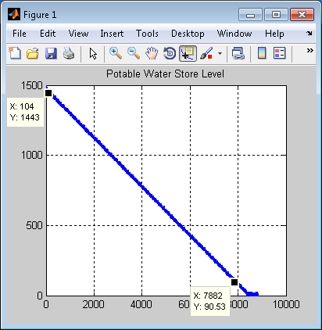

The above depletion rate corresponds to 0.184moles/hour

**Run 5**

Renewed run with all ISRU introduced (results file: BaselineHDUwithLettuceAllisruConvergedV2.mat)

System converges – o2 store and n2 store levels behave similarly to before

